The Company:

A Design & Engineering Company floated in May 2013 with focus on providing Design solutions to all types of industries .

Key Strengths:

- Special Purpose Machine conception,Design and proving.
- 3D Printing,Rapid Prototyping and Scale Models
- Precision machined and cast Parts manufacturing
- New Product Design,Development
- Lean Manufacturing and Best Practices implementation
- Value Engineering and Implementation
- Root Cause Analyses and Problem Solving

Infrastructure:

- VMC(LMW make JV55)
- CNC Lathe(ACE Make Jobber LM)
- CNC lathe(ACE Make SJE-10)
- Fabrication facilities(ARC/MIG/TIG Welding)
- Assembly shop
- 3D Modelling and Analysis
- 3D Printer

Prominent projects executed:

- Design of Special Machines for Site Applications
- Octogonal Stainless Steel Barrel polishing machines
- Concept Workstations
- Roller Conveyor tables

Customer Specific Machines:

 | 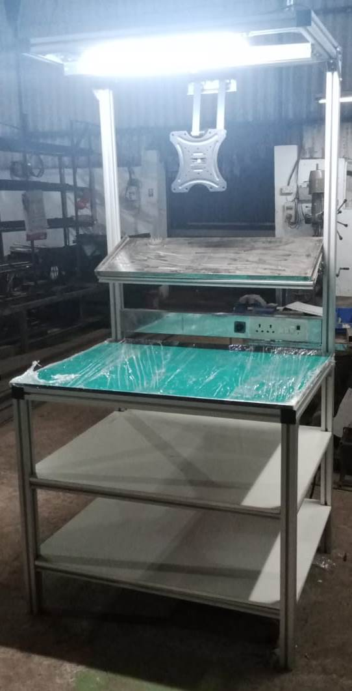 |  |  |  | 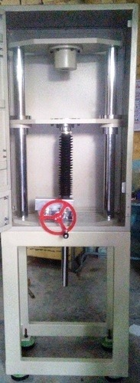  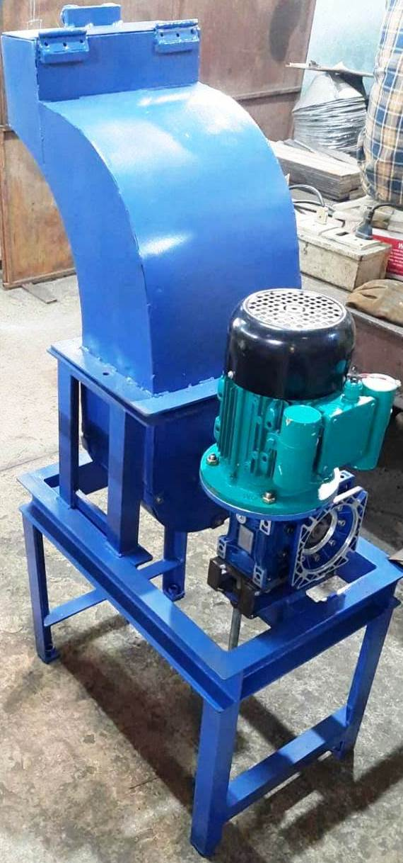

Customer Specific Prototypes:
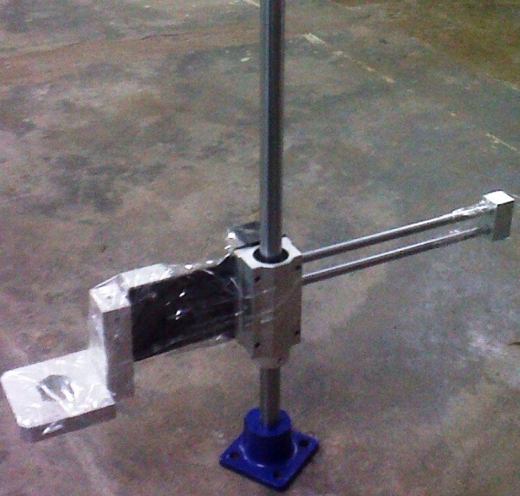

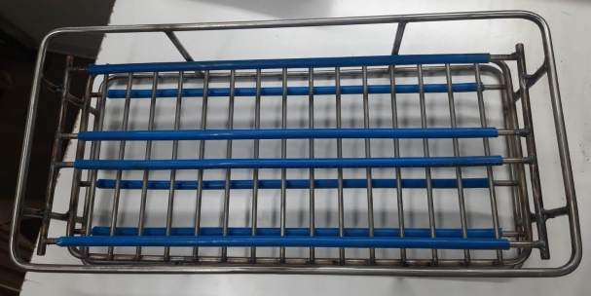
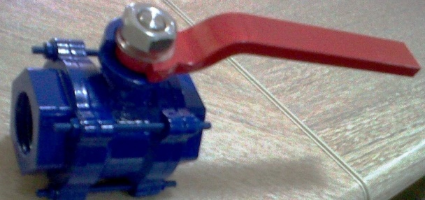
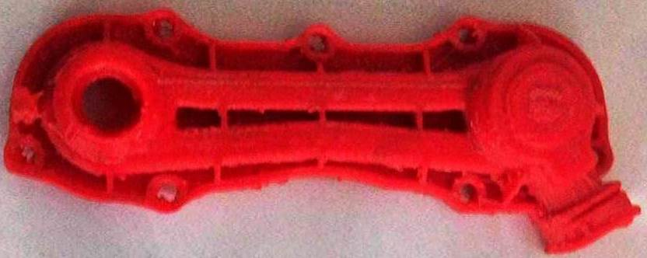

Precision Fabricated and Machined parts:
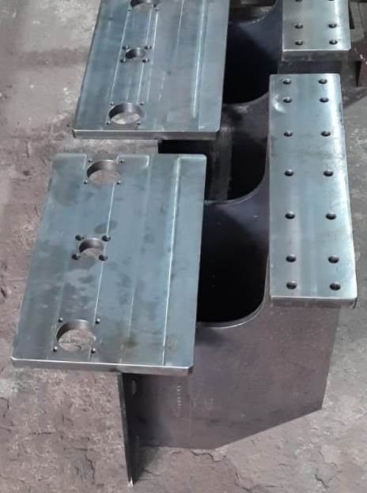
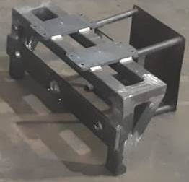
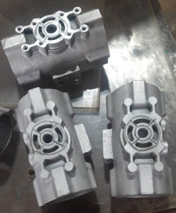
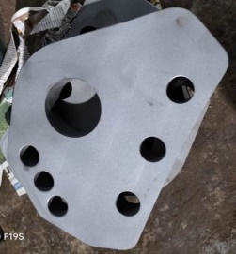

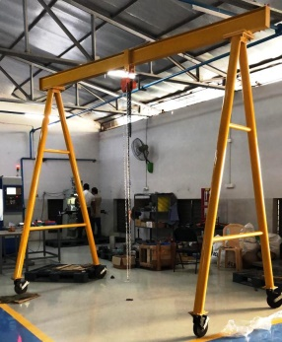
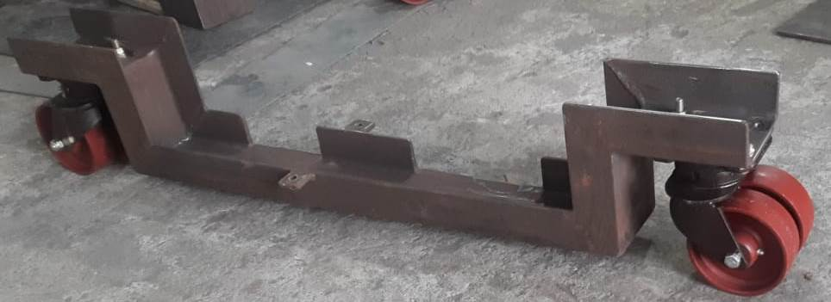
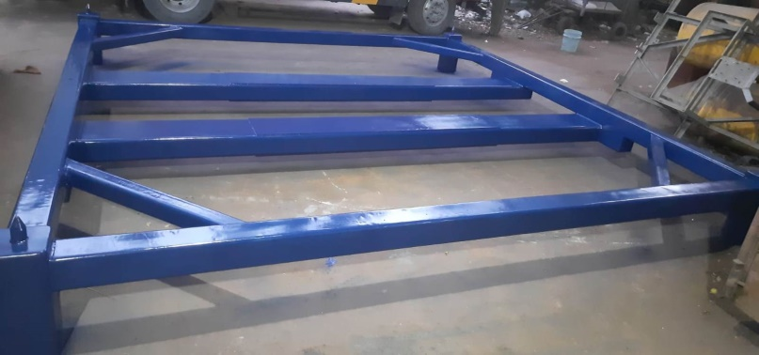
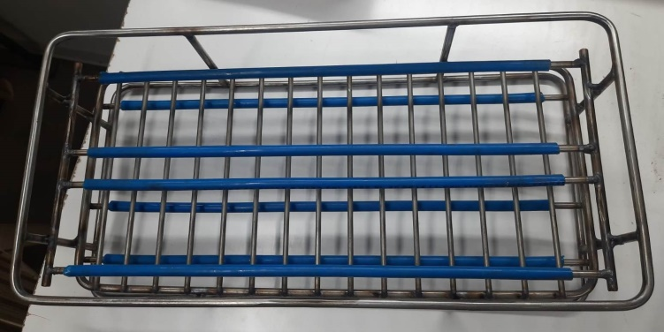
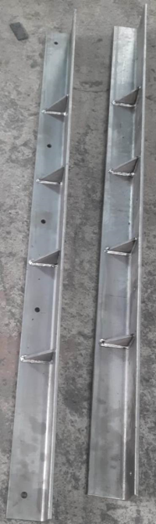
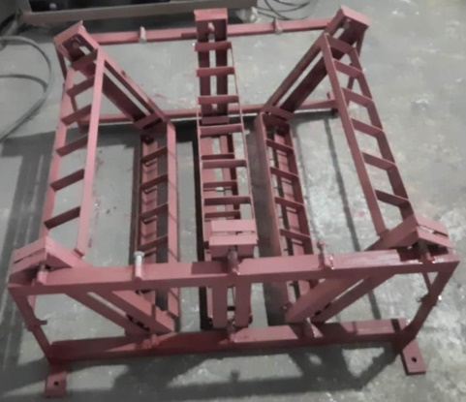

Sheetmetal and Pressed Parts
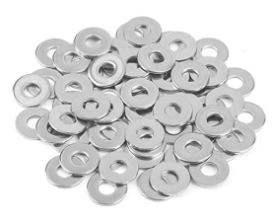 |  | 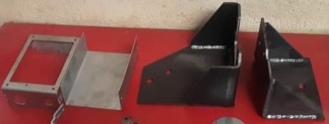
 |  |  | 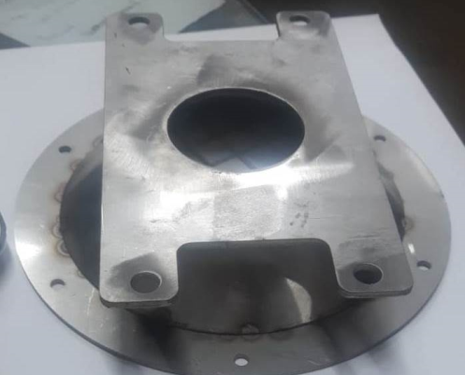 |  |  |  | 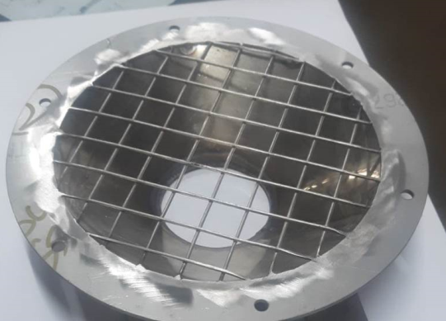
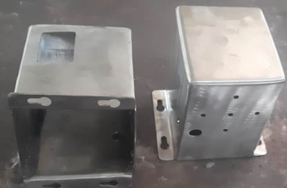
Customers:

- L&T Engineering Services,Chennai
- Baliga Lighting Equipments Private Limited,Chennai
- Eruvaka Technologies Private Limited,Vijayawada
- TI Diamond chain,Chennai
- Jai Balaji Fabricators,Chennai
- Rotork Controls,Chennai
- GK Metals,Chennai
- ITC,Chennai
- Sanyata Actuation and Fluid Engineering,Chennai
- Geeno Tech Services,Chennai
- Superkraft,Chennai
- Insaplex,Chennai
- Ellar Metal Parts,Chennai

Contacts:
M.Mathivanisri –Director
Ph: 919841938829 Email:mathivanisri77@yahoo.co.in A.Neeleshwaran – Business Development Manager Ph: 91 9789066495 Email : neeleshwaran@gmail.com

